**Shri G.S. Institute of Technology and Science**

**Indore (M.P.)**

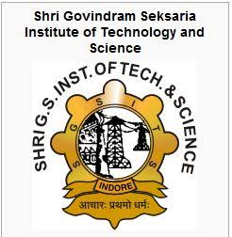

**Computer Science and Engineering Department**

Dec 2015 - May 2016

**Software Engineering**

A project On

**Student Management System**

**Submitted By:- Submitted to :-**

Anand Sajankar Ms. Jyoti Tiwari

(AB24510) Ms. Preeti Khare

Burhan Dabriwal

(AB24519)